8.Implement in aggregation function (e.g,sum,count,avg) on data base record run on mysql workbench.

Create a Table

create table employees7(
emp_id int primary key auto_increment,
emp_name varchar (50),
department varchar(30),
salary decimal(10,2)
);
desc employees7;

Insert some sample data

insert into employees7(emp_name,department,salary)values
('sonu','it',40000),
('neha','it',55000),
('khushi','hr',42000),
('ranu','finance',40000),
('gaytri','finance',35000),
('puja','hr',28000);
select*from employees7;

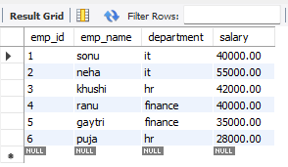

SUM()Total salary per department
select department,sum(salary)as department_salary
from employees7
group by department;

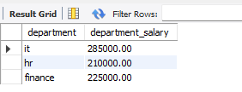

COUNT()employees in each department

select department,count(*)as total_employees7
from employees7
group by department;

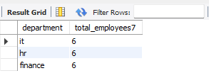

AVG()Average salary per department

select department,avg(salary)as avg_salary
from employees8
group by department;


